Carbay.ph

Landing page

cars

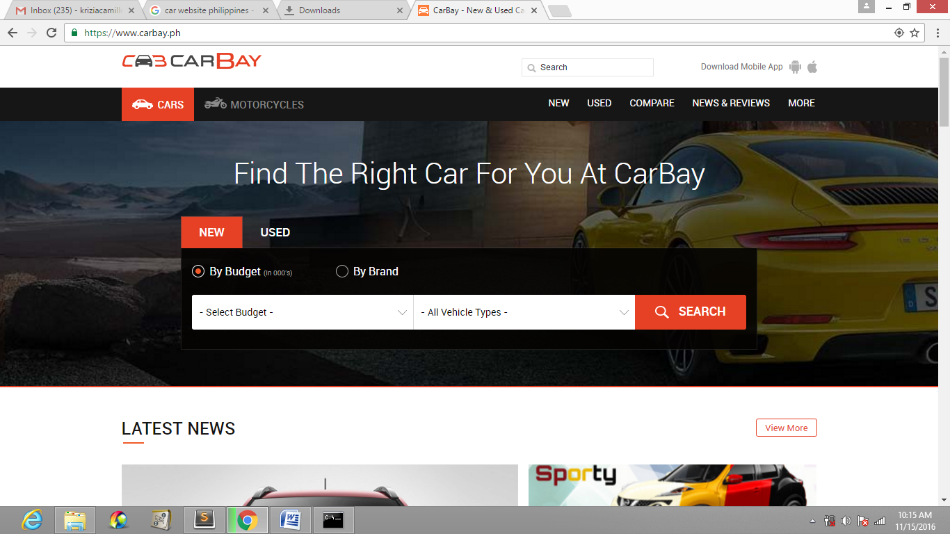

By the color scheme of this website, it’s a nice color to use if their target clients will be car enthusiasts.

Again, just like the other websites, they use a filter-search box. This time they use 2 tabs (new and used) and under that 2 radio buttons by budget and by brand. If by Budget is selected, the dropdown will show the list of all vehicle types while 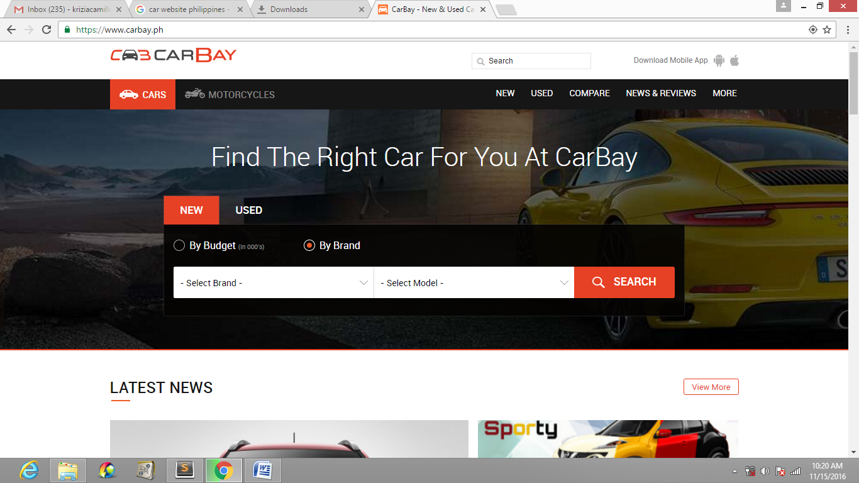

If by brand is selected, the list of car models is selected.

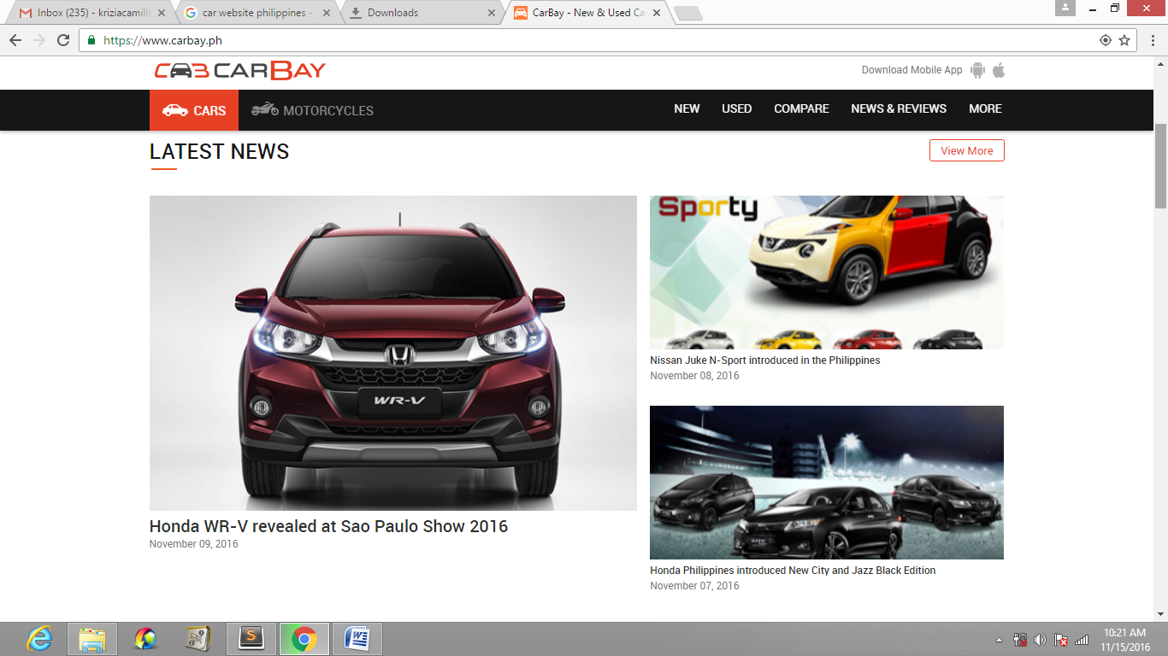

The website got the latest news, if the picture is selected

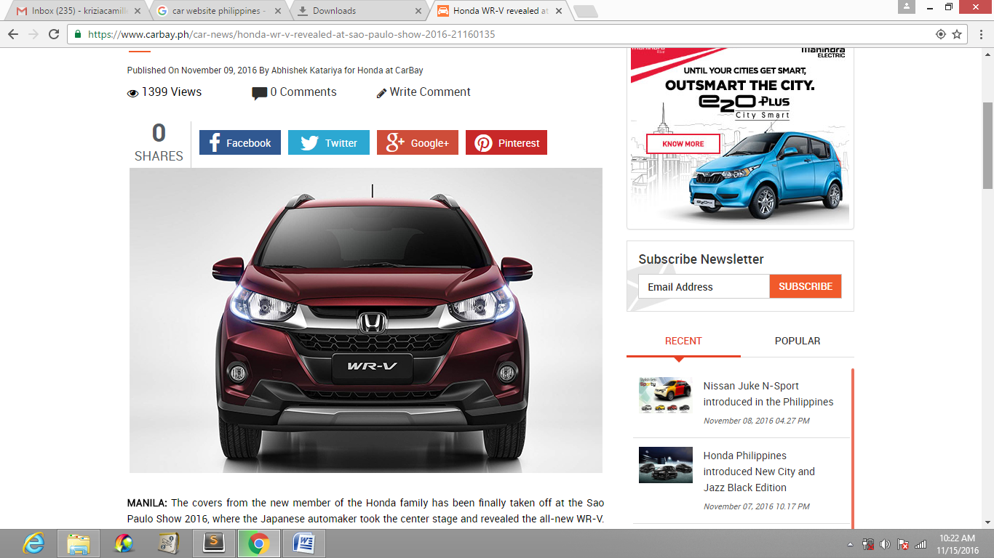

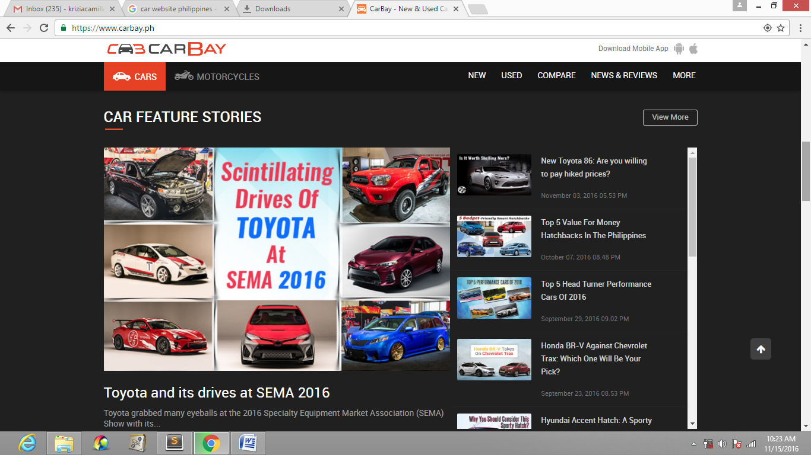The website also got feature stories of cars

If view more is selected

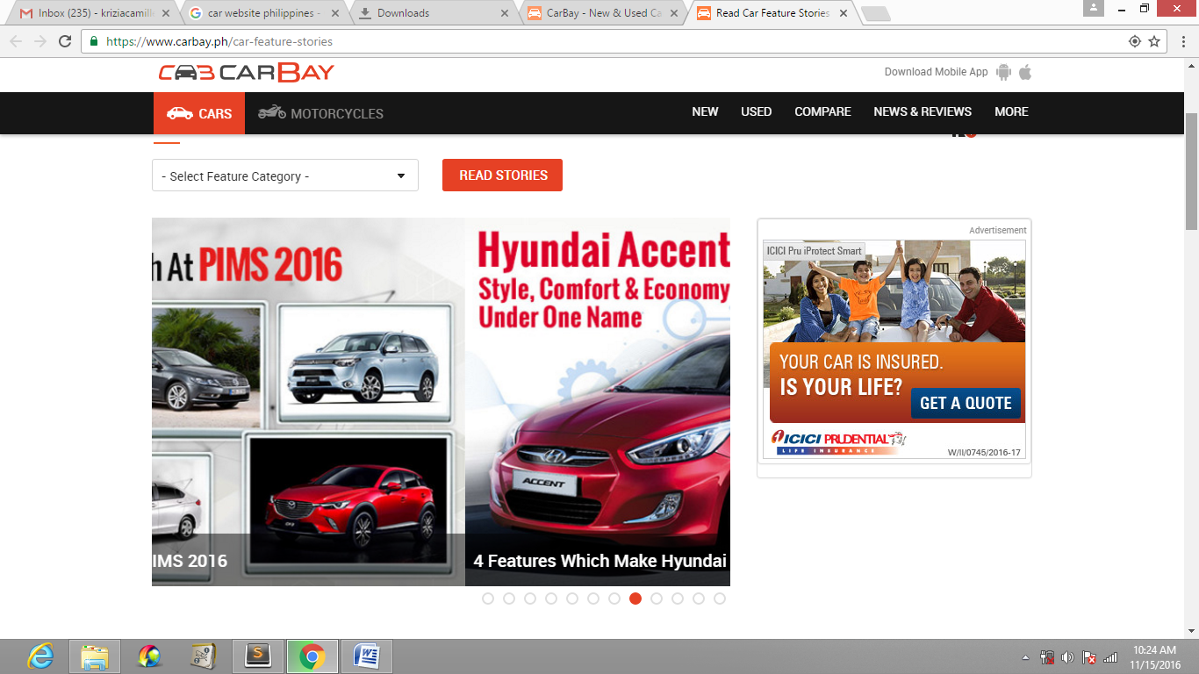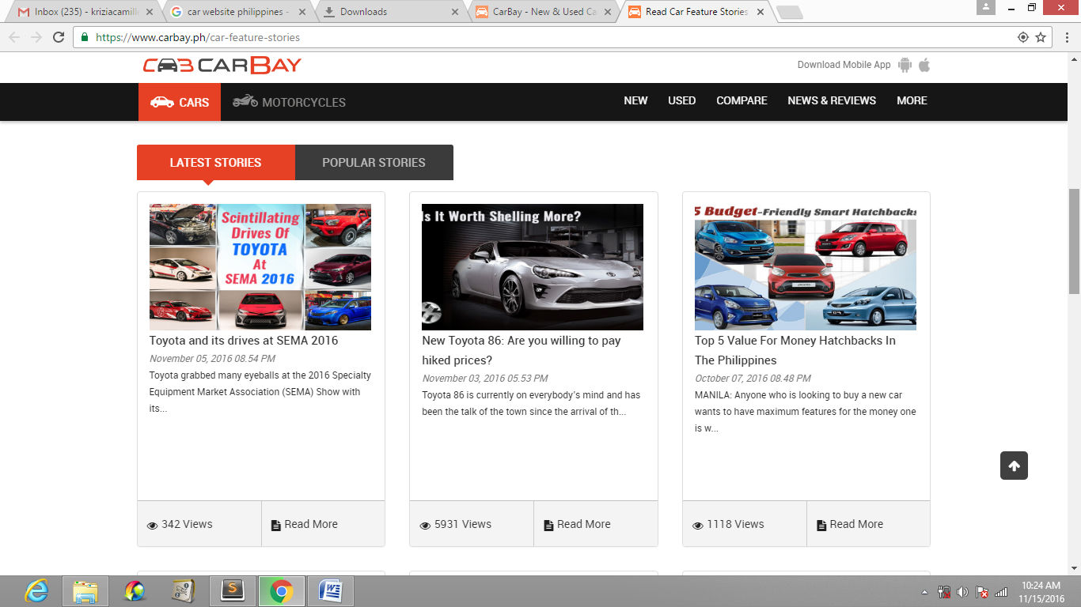

The landing page also got a list of cars that will be launched in a specific year.

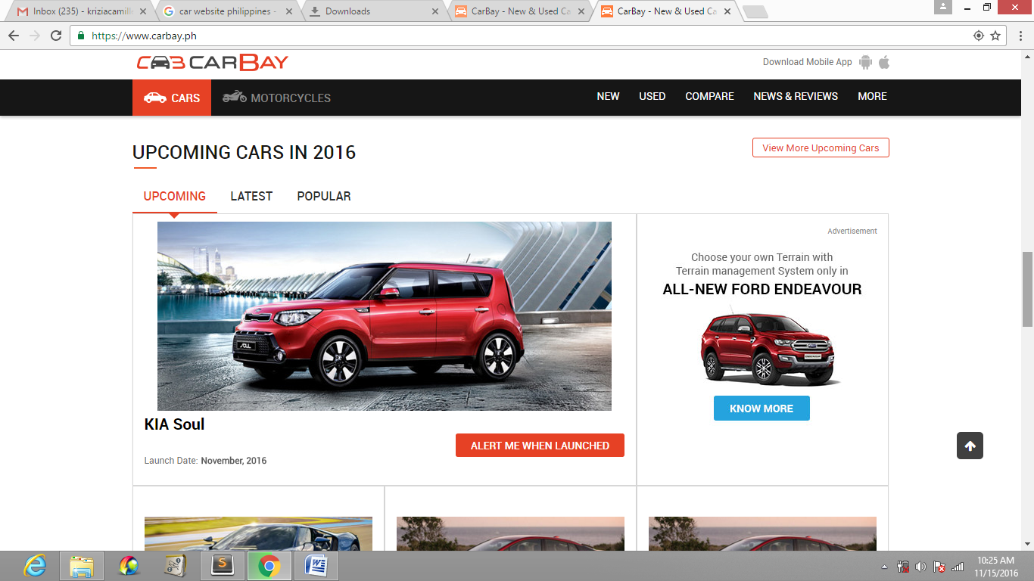

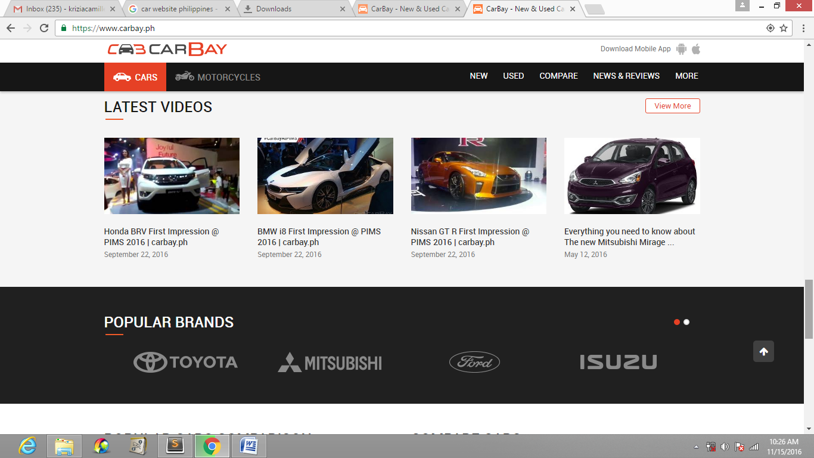

List of car videos and popular brands

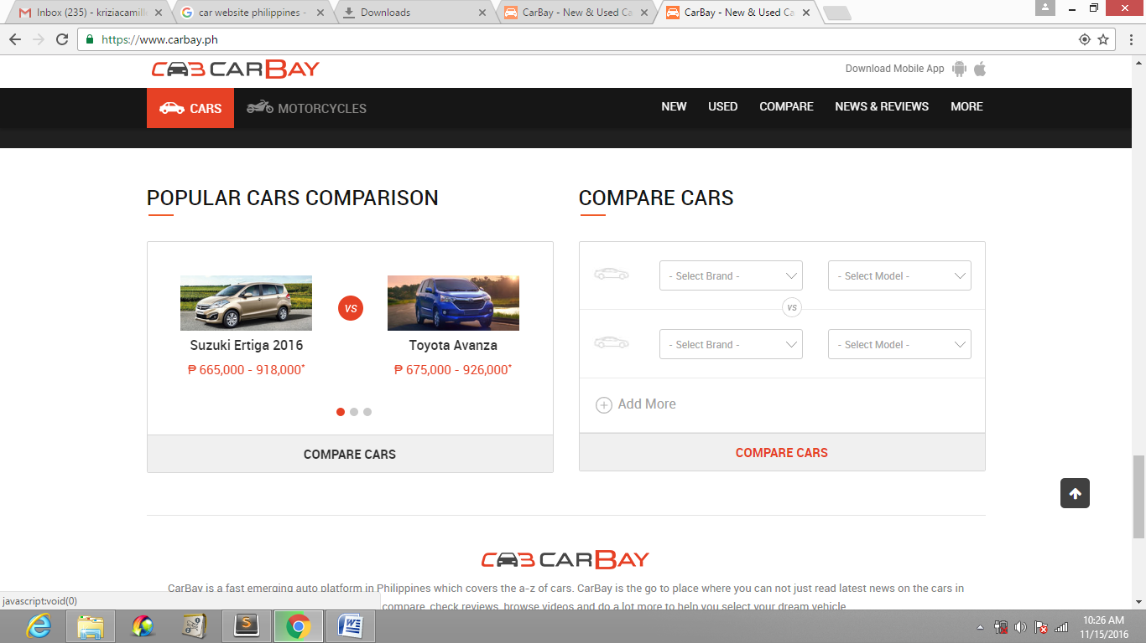

Most cars that people compared and a custom make.

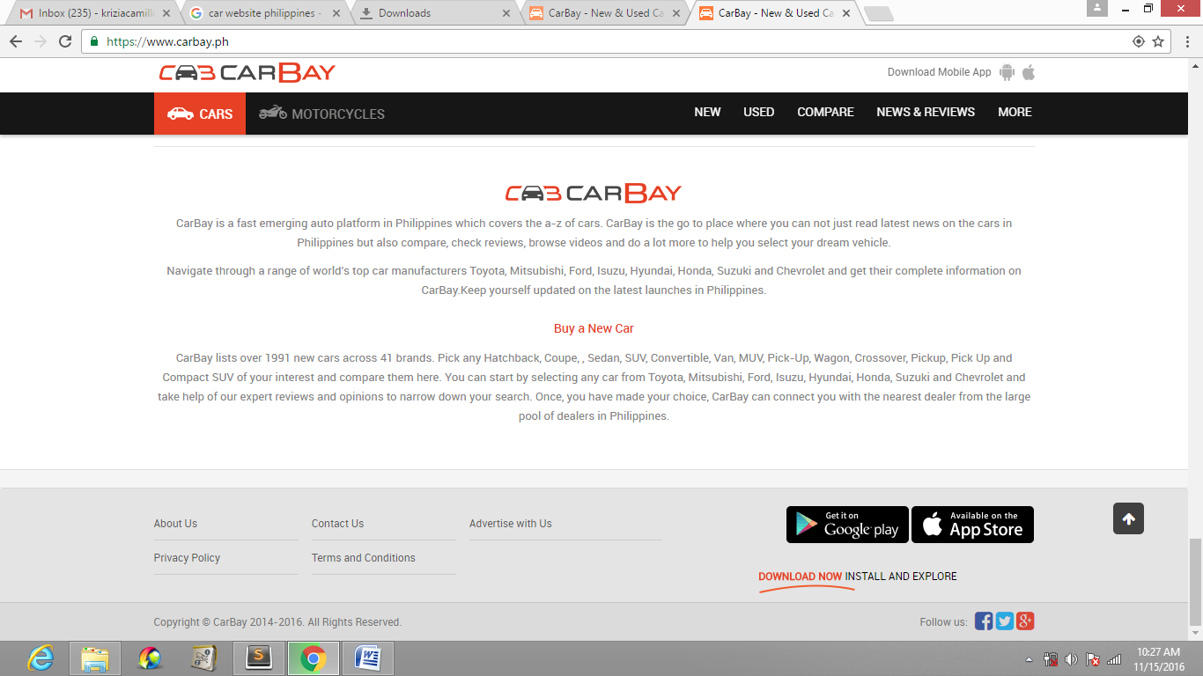

About carbay.

They also got a landing page? for motorcycles

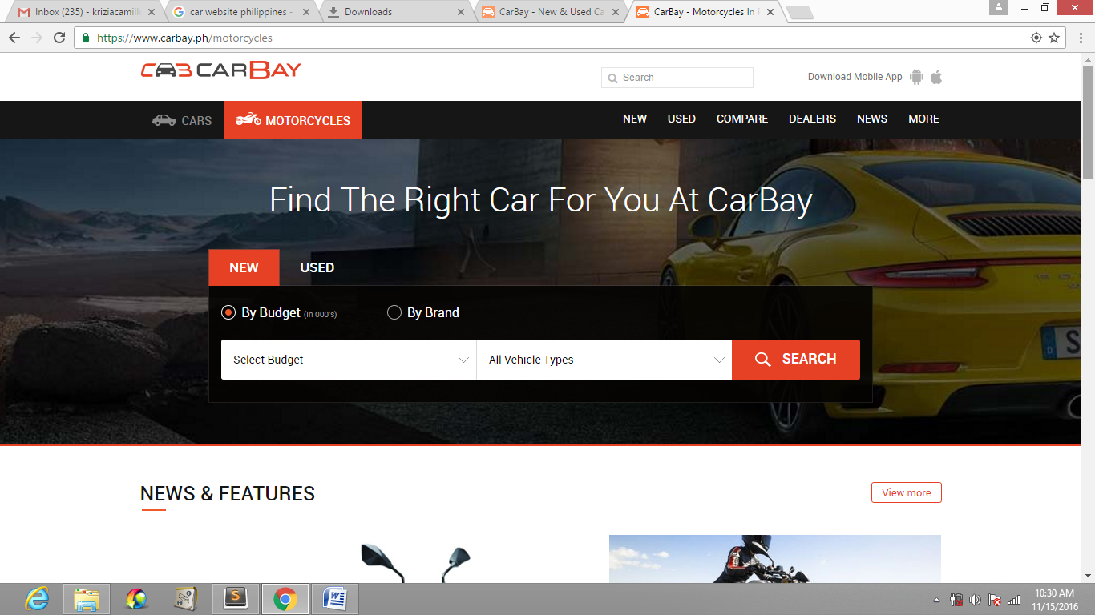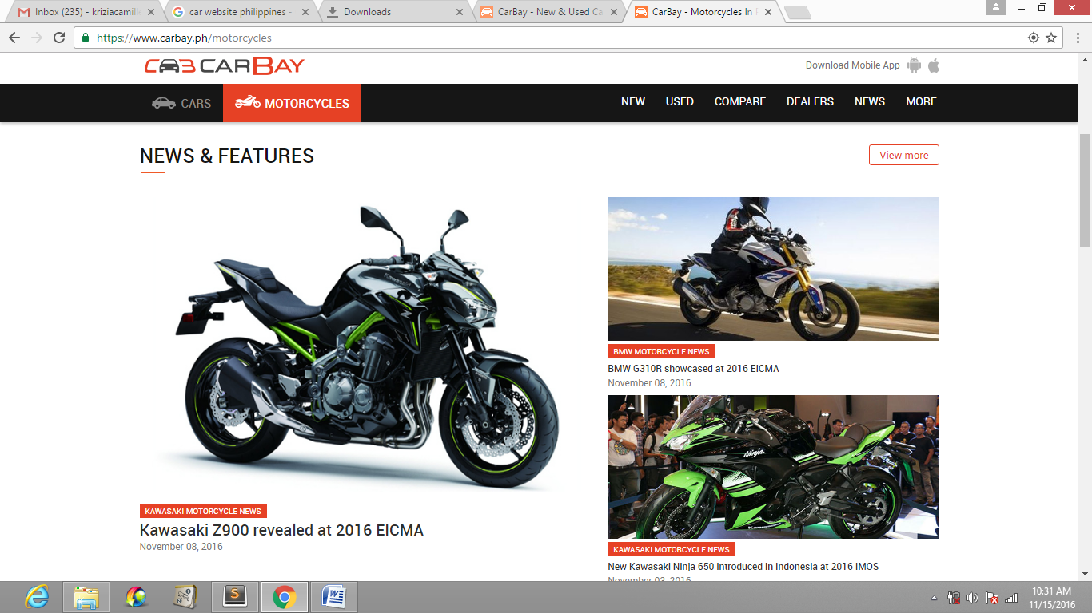

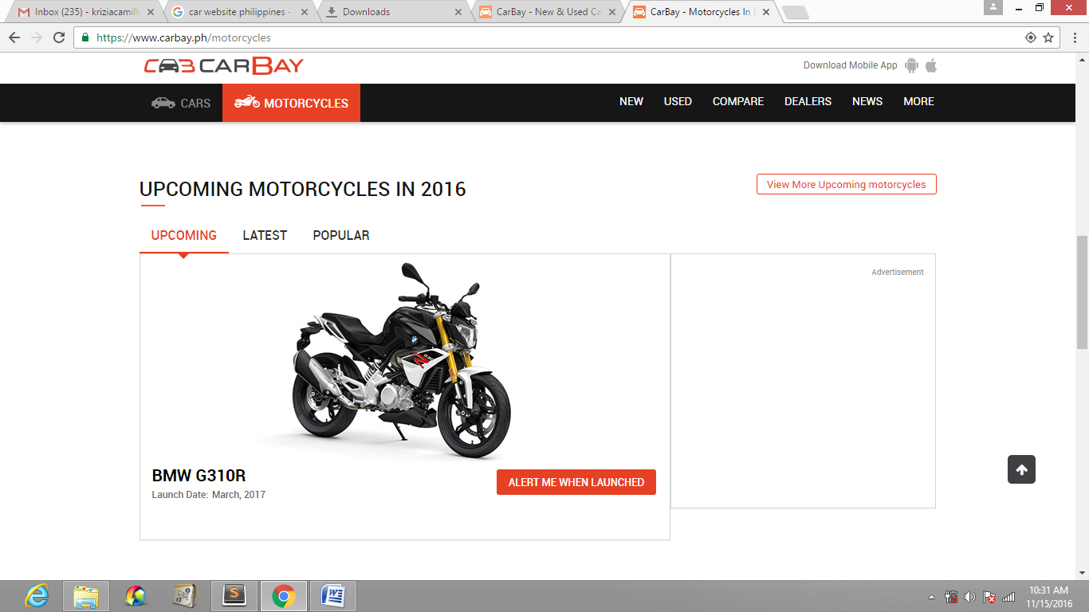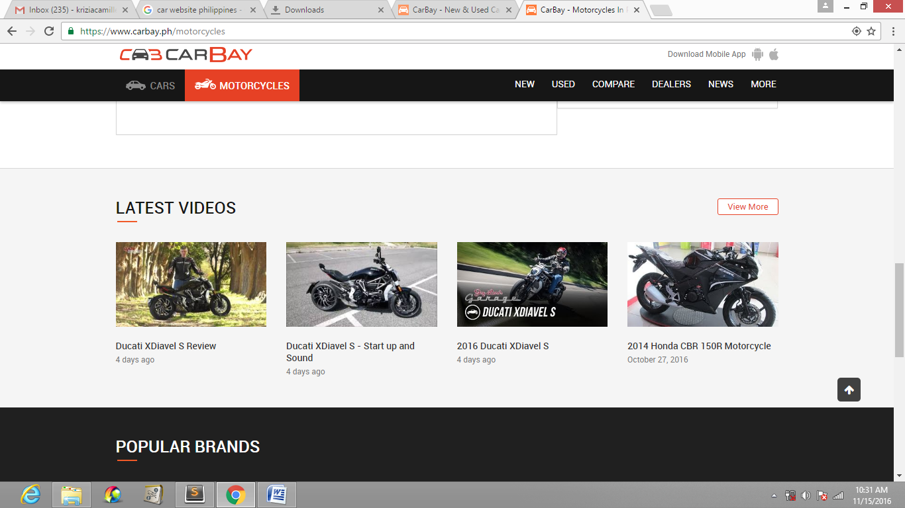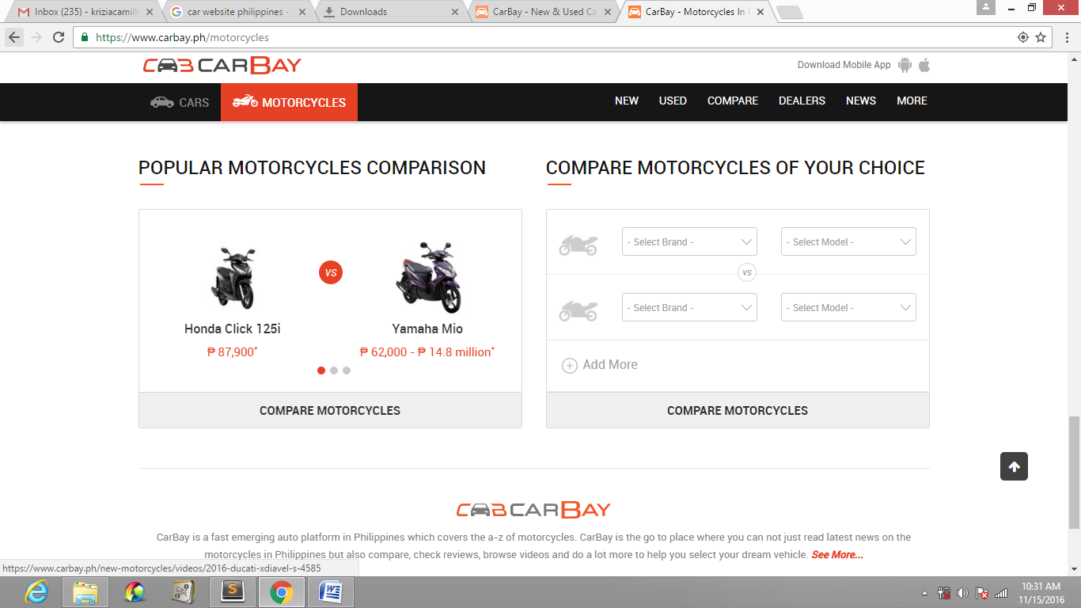

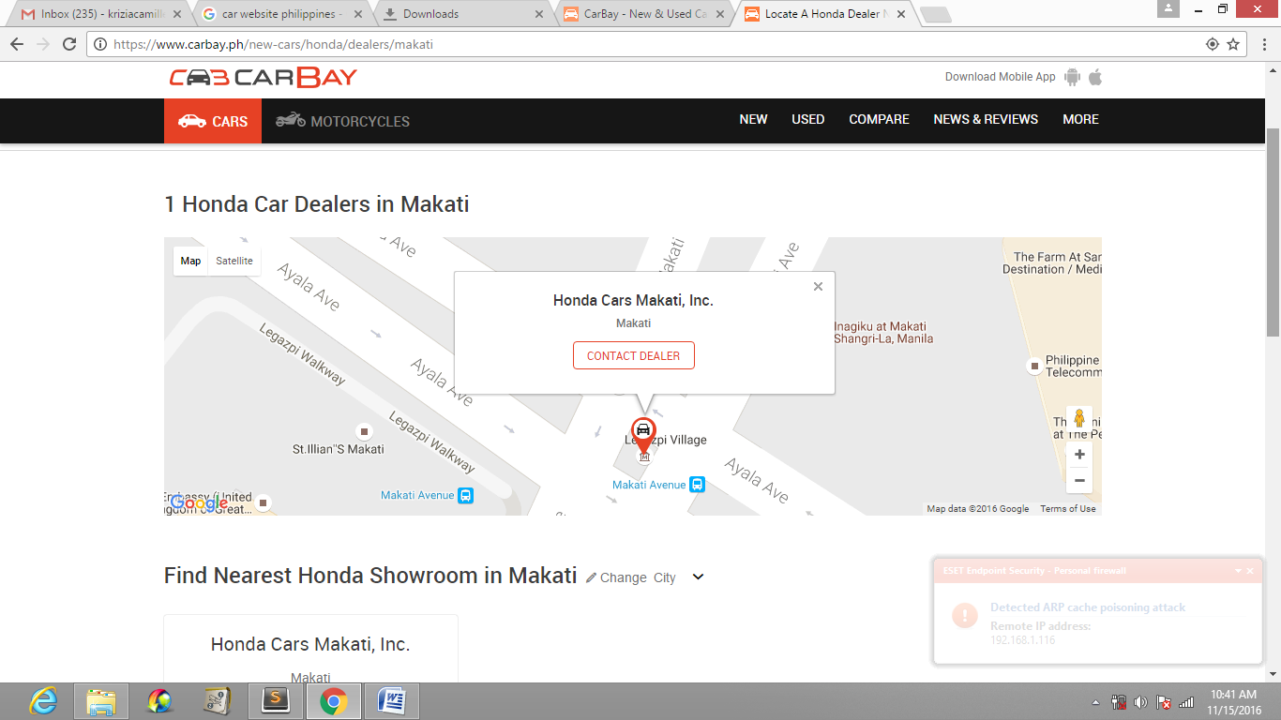

Map of dealers in a specific place and model.

